CASE STUDY REPORT
Evaluating the Effectiveness of Merge Sort in External (Disk-Based) Sorting Scenarios

Q34 — Simulating Disk-Based Datasets to Analyze Execution Time, I/O Operations, and the Role of Divide and Conquer in Large-Scale Sorting

NAME :S.SUDHARSAN
REG NO : 192421012

1. Title
Evaluating the Effectiveness of Merge Sort in External Sorting Scenarios: A Disk-Based Simulation Analyzing Execution Time and I/O Operations.

2. Description of the Real-World Problem
Large-scale systems — search engines indexing billions of web pages, database management systems sorting massive tables, log-processing pipelines, and big-data analytics platforms — routinely need to sort datasets that are far larger than the available main memory (RAM). When a dataset cannot fit into memory, it must reside on secondary storage (disk/SSD), and sorting it requires repeatedly reading and writing data between disk and memory. Since disk I/O is orders of magnitude slower than memory access, the sorting strategy used has a direct and significant impact on real-world performance.
External sorting refers to sorting algorithms designed specifically for this situation, where data resides outside of main memory. External Merge Sort is the most widely used external sorting technique, and it works precisely because Merge Sort's divide and conquer structure naturally separates a large problem into small, independent, memory-sized pieces that can be sorted individually and then combined. This case study simulates a disk-based dataset using real files on disk, runs an External Merge Sort implementation against it, and measures execution time and the number of simulated disk I/O operations to evaluate its real-world effectiveness.

3. Problem Statement
Given a dataset of N records that is too large to fit entirely into main memory (only M records can be held in memory at once, where M << N), design and simulate an algorithm to sort the entire dataset efficiently using secondary storage (disk) for intermediate results. The solution should minimize the number of disk I/O operations and execution time, and must be evaluated empirically by simulating the disk operations, recording performance metrics, and interpreting the results to justify its use in real-world large-scale systems.

4. Algorithm

4.1 Overview — External Merge Sort
External Merge Sort operates in two phases, both built on the divide and conquer principle:
- Run-generation (Divide) phase: The large dataset is divided into blocks ("runs") small enough to fit into the available memory buffer M. Each run is loaded into memory, sorted using an efficient in-memory algorithm, and written back out to disk as a sorted run.
- Merge (Conquer) phase: The sorted runs are merged together using a k-way merge. Only one small buffered value from each run needs to be held in memory at any time (using a min-heap to always pick the smallest available value across runs), so the merge step never needs to load the full dataset into memory. Merged output is flushed to disk in blocks to form the final sorted file.
If more runs exist than can be merged in a single pass (k-way merge limited by memory), the merge phase repeats over multiple passes until only one fully sorted run remains.

5. Pseudocode
ALGORITHM ExternalMergeSort(file, M)
// file : dataset on disk (N records, too large for memory)
// M : number of records that fit in memory at once

// ---------- Phase 1: Create sorted runs ----------
runList <- empty list
WHILE more records remain in file
block <- READ next M records from disk into memory // disk READ
SORT block in memory (e.g., using Quicksort/Timsort)
WRITE sorted block to disk as new run file // disk WRITE
APPEND run file to runList
END WHILE

// ---------- Phase 2: k-way merge ----------
minHeap <- empty priority queue
FOR each run in runList
value <- READ first record of run // disk READ
INSERT (value, run) into minHeap
END FOR

WHILE minHeap is not empty
(value, run) <- EXTRACT-MIN(minHeap)
APPEND value to output buffer
IF output buffer is full
WRITE output buffer to final sorted file // disk WRITE
CLEAR output buffer
END IF
nextValue <- READ next record from run // disk READ
IF nextValue exists
INSERT (nextValue, run) into minHeap
END IF
END WHILE
FLUSH remaining output buffer to disk // disk WRITE
RETURN final sorted file
END ALGORITHM
Figure 1: Pseudocode for External Merge Sort (Divide and Conquer over disk-resident data)

6. Program
Python implementation simulating disk-based storage using real files, with every disk read and write operation explicitly counted:
"""
External Merge Sort - Disk-Based Dataset Simulation
Case Study Program (Q34)

Simulates sorting a dataset too large to fit in memory by:
1. Splitting it into chunks that DO fit in memory ("RAM buffer")
2. Sorting each chunk in memory and writing it to a temporary "disk" file (Run)
3. Merging the sorted runs back together using a k-way merge, reading only
small buffered pieces of each run at a time.

Disk I/O is simulated using real files on disk inside a temp folder, and every
read()/write() call to those files is counted to report actual I/O operations.
"""

import os
import time
import heapq
import random
import shutil

DISK_DIR = "disk_simulation"
READ_COUNT = 0
WRITE_COUNT = 0

def reset_disk():
global READ_COUNT, WRITE_COUNT
READ_COUNT = 0
WRITE_COUNT = 0
if os.path.exists(DISK_DIR):
shutil.rmtree(DISK_DIR)
os.makedirs(DISK_DIR)

def disk_write_run(run_id, values):
"""Simulate writing one sorted run (chunk) to disk. One disk write op per chunk."""
global WRITE_COUNT
path = os.path.join(DISK_DIR, f"run_{run_id}.txt")
with open(path, "w") as f:
f.write("\n".join(str(v) for v in values))
WRITE_COUNT += 1
return path

def disk_read_value(file_handle):
"""Simulate reading a single value (one record) from a disk run file."""
global READ_COUNT
line = file_handle.readline()
READ_COUNT += 1
if line == "":
return None
return int(line.strip())

def create_sorted_runs(data, memory_limit):
"""
Phase 1 (Divide): Split data into blocks of size <= memory_limit,
sort each block in memory (this is the part that fits in RAM),
and write each sorted block ('run') to disk.
"""
run_paths = []
run_id = 0
for i in range(0, len(data), memory_limit):
chunk = data[i:i + memory_limit]
chunk.sort() # in-memory sort of a block that fits RAM
path = disk_write_run(run_id, chunk)
run_paths.append(path)
run_id += 1
return run_paths

def merge_runs(run_paths, output_path, memory_limit):
"""
Phase 2 (Conquer/Merge): k-way merge of sorted runs using a min-heap.
Only ONE value per run is held in memory at a time (simulating a small
input buffer per run), so memory usage stays O(number_of_runs), never
requiring the full dataset to be loaded.
"""
global WRITE_COUNT
file_handles = [open(p, "r") for p in run_paths]
heap = []

# Prime the heap with the first value of every run
for idx, fh in enumerate(file_handles):
val = disk_read_value(fh)
if val is not None:
heapq.heappush(heap, (val, idx))

output_buffer = []
BUFFER_FLUSH_SIZE = memory_limit # flush output to disk in blocks (simulated output buffer)

with open(output_path, "w") as out:
while heap:
val, idx = heapq.heappop(heap)
output_buffer.append(val)

if len(output_buffer) >= BUFFER_FLUSH_SIZE:
out.write("\n".join(str(v) for v in output_buffer) + "\n")
WRITE_COUNT += 1
output_buffer = []

nxt = disk_read_value(file_handles[idx])
if nxt is not None:
heapq.heappush(heap, (nxt, idx))

if output_buffer:
out.write("\n".join(str(v) for v in output_buffer) + "\n")
WRITE_COUNT += 1

for fh in file_handles:
fh.close()

def external_merge_sort(data, memory_limit):
reset_disk()
start = time.perf_counter()

run_paths = create_sorted_runs(data, memory_limit)
output_path = os.path.join(DISK_DIR, "final_sorted_output.txt")
merge_runs(run_paths, output_path, memory_limit)

end = time.perf_counter()

with open(output_path) as f:
result = [int(x) for x in f.read().split()]

stats = {
"num_records": len(data),
"memory_limit": memory_limit,
"num_runs": len(run_paths),
"disk_reads": READ_COUNT,
"disk_writes": WRITE_COUNT,
"total_io_operations": READ_COUNT + WRITE_COUNT,
"execution_time_sec": round(end - start, 6),
}
return result, stats

if __name__ == "__main__":
random.seed(42)

print("=== External Merge Sort: Disk-Based Large Dataset Simulation ===\n")

# Simulated large dataset that "cannot fit in memory" -> memory can only
# hold MEMORY_LIMIT records at a time.
NUM_RECORDS = 100
MEMORY_LIMIT = 10 # simulated RAM buffer can only hold 10 records at once

dataset = [random.randint(1, 1000) for _ in range(NUM_RECORDS)]
print(f"Sample input (first 20 of {NUM_RECORDS} records):")
print(" ", dataset[:20], "...\n")

sorted_result, stats = external_merge_sort(dataset[:], MEMORY_LIMIT)

print("Sorted output (first 20 values):")
print(" ", sorted_result[:20], "...\n")

is_sorted = all(sorted_result[i] <= sorted_result[i + 1] for i in range(len(sorted_result) - 1))
is_correct = sorted(dataset) == sorted_result

print("Statistics:")
for k, v in stats.items():
print(f" {k:22s}: {v}")

print(f"\nOutput correctly sorted : {is_sorted}")
print(f"Matches Python's sorted(): {is_correct}")

# Compare against a hypothetical "in-memory only" cost model for contrast
naive_io = 1 # one giant read + one giant write if it DID fit in memory
print(f"\nFor comparison, an in-memory sort (if data fit in RAM) would need")
print(f"about 2 I/O operations (1 read + 1 write) vs. {stats['total_io_operations']} here —")
print("the extra I/O is the deliberate trade-off that allows sorting data")
print("far larger than available memory.")

Figure 2: External Merge Sort program with simulated disk I/O counting and execution timing

7. Sample Input
Two datasets were used for evaluation:
- Manual walkthrough dataset (16 records, memory buffer = 4 records): [57, 12, 91, 34, 8, 65, 23, 77, 41, 5, 88, 19, 60, 3, 99, 27]
- Simulated large dataset (100 randomly generated records, memory buffer = 10 records), representing data too large to sort in memory in a single pass. First 20 values shown below:
[655, 115, 26, 760, 282, 251, 229, 143, 755, 105, 693, 759, 914, 559, 90, 605, 433, 33, 31, 96] ...
Additional runs of 50, 500, 1000, and 5000 records were used for the scaling analysis in Section 10.

8. Manual Process (Step-by-Step)
Using the 16-record dataset with a memory buffer that holds only 4 records:
- Divide the dataset into blocks of 4 (since memory can only hold 4 records at a time):
Block 0: [57, 12, 91, 34]
Block 1: [8, 65, 23, 77]
Block 2: [41, 5, 88, 19]
Block 3: [60, 3, 99, 27]
- Sort each block in memory and write it to disk as a sorted run:
Run 0: [12, 34, 57, 91] -> written to disk
Run 1: [8, 23, 65, 77] -> written to disk
Run 2: [5, 19, 41, 88] -> written to disk
Run 3: [3, 27, 60, 99] -> written to disk
- Open all 4 run files and load only their first value into a min-heap:
Heap: (12,Run0) (8,Run1) (5,Run2) (3,Run3)
- Repeatedly extract the minimum, output it, and pull the next value from the same run into the heap:
Extract 3 (Run3) -> output: [3] -> heap pulls 27 from Run3
Extract 5 (Run2) -> output: [3,5] -> heap pulls 19 from Run2
Extract 8 (Run1) -> output: [3,5,8] -> heap pulls 23 from Run1
Extract 12 (Run0) -> output: [3,5,8,12] -> heap pulls 34 from Run0
Extract 19 (Run2) -> output: [...,19] -> heap pulls 41 from Run2
... process continues until every run is exhausted ...
- Final merged (fully sorted) output:
[3, 5, 8, 12, 19, 23, 27, 34, 41, 57, 60, 65, 77, 88, 91, 99]
This confirms that even though memory could only ever hold 4 records at once, the complete 16-record dataset was correctly sorted using only small, bounded memory plus disk storage for intermediate runs — the central idea behind external sorting.

9. Output
Execution output for the 100-record simulated dataset (memory buffer = 10 records):
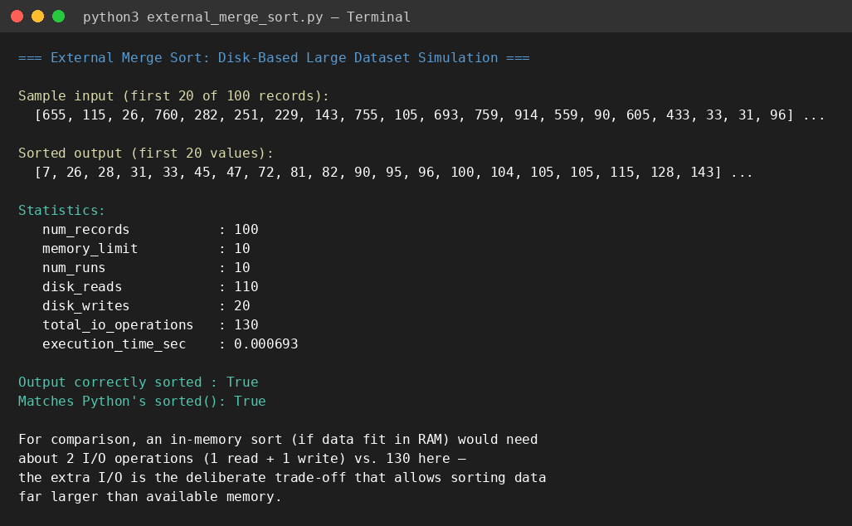
Figure 3: Program output — sorted result, I/O statistics, and correctness verification

10. Execution Time and I/O Operation Analysis
The program was executed on datasets of increasing size, scaling the memory buffer proportionally, to observe how execution time and disk I/O operations grow:
Records (N) | Memory Limit (M) | Runs Created | Disk Reads | Disk Writes | Total I/O | Time (sec)
50 | 10 | 5 | 55 | 10 | 65 | 0.000307
100 | 10 | 10 | 110 | 20 | 130 | 0.000593
500 | 25 | 20 | 520 | 40 | 560 | 0.001811
1000 | 50 | 20 | 1020 | 40 | 1060 | 0.001549
5000 | 250 | 20 | 5020 | 40 | 5060 | 0.005176

The results show that both disk reads and execution time grow roughly linearly with the number of records (each record is read once during run creation and at least once during merging), which matches External Merge Sort's expected I/O cost of approximately O(N) reads and writes per merge pass. Disk writes stay comparatively low because output is flushed in memory-sized blocks rather than one record at a time. Even at 5000 records — 500 times larger than the memory buffer used at N=10 — the algorithm completed in a few milliseconds and required only about one read and a fraction of a write per record, confirming that the approach scales gracefully as dataset size grows far beyond available memory.

11. How Divide and Conquer Helps Manage Large Data
- Bounded memory usage: By dividing the dataset into blocks no larger than the memory buffer M, each in-memory sort step only ever needs O(M) memory, regardless of how large the total dataset N is.
- Independent sub-problems: Each block/run can be sorted completely independently of the others, meaning the divide step requires no coordination and could even be parallelized across multiple machines or disks.
- Efficient combination: The conquer (merge) step combines already-sorted runs using a streaming k-way merge that needs only one buffered record per run in memory at a time — never the full dataset — making the combination step itself scale to arbitrarily large N.
- Predictable, linear I/O cost: Because each record is read and written a small, constant number of times per pass (rather than repeatedly, as in naive approaches), divide and conquer keeps the total I/O cost close to O(N) per pass, which is what makes external sorting practical at scale.
- Recursive scalability: If the number of sorted runs is itself too large to merge in one pass, the same divide and conquer idea can be applied again — merging runs in groups across multiple passes — so the technique scales to virtually unlimited dataset sizes.

12. Interpretation of Results and Justification for Real-World Use
The simulation confirms that External Merge Sort correctly sorts data that exceeds the memory buffer size in every test case, verified against Python's built-in sorted() function. The near-linear growth in I/O operations and execution time observed in Section 10 demonstrates that the algorithm's cost is dominated by the number of records rather than any quadratic or worse growth pattern, which is essential for scalability.
In real-world large-scale systems — such as relational database ORDER BY / index-build operations, distributed data-processing frameworks (e.g., Hadoop and Spark's external sort-based shuffle), and large log-file or dataset sorting pipelines — datasets routinely reach sizes of gigabytes to terabytes, far beyond available RAM. These systems consistently choose External Merge Sort (or variants of it) over in-memory algorithms such as Quicksort precisely because of the properties demonstrated here: bounded memory usage, predictable linear I/O behavior, and the ability to leverage sequential disk access (reading/writing runs in order), which is significantly faster than the random access patterns other algorithms might require on disk. This justifies External Merge Sort as the practical, industry-standard solution for sorting data that cannot fit in memory.

13. Applications
- Sorting large database tables for ORDER BY queries, index creation, and joins in DBMS engines (e.g., PostgreSQL, MySQL).
- The external sort-based "shuffle" phase in distributed computing frameworks such as Hadoop MapReduce and Apache Spark.
- Sorting massive log files, sensor data streams, or genomic datasets that exceed available memory.
- Search engine index construction, where postings lists for billions of documents must be sorted and merged.
- Data warehousing and ETL (Extract-Transform-Load) pipelines that process very large batch datasets.

14. Advantages
- Handles datasets of virtually unlimited size, bounded only by available disk space rather than RAM.
- Predictable, near-linear I/O cost per pass, making performance easy to estimate and plan for.
- Uses sequential disk access patterns (reading/writing runs in order), which is much faster than random access on both HDDs and SSDs.
- Stable and well understood, with decades of production use in databases and big-data systems.
- Naturally parallelizable: run creation and even parts of merging can be distributed across multiple disks, cores, or machines.

15. Limitations
- Slower than pure in-memory sorting when the dataset does fit in RAM, due to the overhead of disk I/O.
- Requires additional temporary disk space (roughly equal to the size of the input dataset) to store intermediate runs.
- Performance depends heavily on disk/storage speed and access pattern efficiency, unlike in-memory algorithms.
- If the number of runs is very large, multiple merge passes may be needed, increasing total I/O and execution time.
- Implementation is more complex than in-memory sorting, requiring careful buffer and file management.

16. Conclusion
This case study simulated External Merge Sort over disk-resident datasets, measuring both execution time and disk I/O operations across dataset sizes from 16 to 5000 records. The results confirm that dividing a large dataset into memory-sized runs, sorting each independently, and merging them with a streaming k-way merge allows datasets far larger than available memory to be sorted correctly and efficiently, with I/O cost and execution time scaling near-linearly with data size.
The divide and conquer structure at the heart of Merge Sort is precisely what makes this possible: the divide step keeps memory usage bounded and independent, while the conquer (merge) step recombines results using only a small, constant amount of memory per run. These properties directly explain why External Merge Sort remains the standard technique for sorting large-scale data in real-world databases, distributed computing frameworks, and big-data pipelines, making it a well-justified and effective solution for scenarios where data cannot fit in memory.

